National Registrations User Guide

Contents

Overview 2
Login Page 3
Home Page 4
Player Details 5
Registrations Awaiting Approval 5
Rejected Registrations 6
Cancelled Registrations 6
Cancel a Registration 7
Registration Forms 8
Pre-Filled Registration Form 8
Blank Registration Form 9
Process Registration Form 10
Blank Registration Form 10
Step One 11
Step Two 11
Step Three 13
Step Four 13
Pre-Filled Form 15
Player Search 17
FAQ 19
Feedback 19
Contact Us 20
Logout 20

Version Control | Author | Date
1 | Craig Brown | 21st October 2010

Overview

The Scottish FA National Registrations system is intended to provide the capability for the Scottish Womens Football to process, cancel and query player registrations online.

The National Registrations system provides:

- The ability for users to submit a new registration for a new player for their club.
- The ability for users to cancel a player currently registered with their club.
- The ability for users to query if a player is currently registered with a club.
- The ability for users to query accepted, pending, rejected and cancelled registrations for their club.

The system contains a number of sections as follows: -

Home – the Home section displays a list of all currently registered players for the current season. There are links to view pending, rejected and cancelled registrations within this section. There is also the ability to either produce a new registration form or submit a completed registration form in this section.

Player Search – the Player Search section allows the user to query a specific player to determine if they are eligible to be registered for their team.

FAQ – a list of Frequently Asked Questions, and the answers, relating to the system.

Feedback – supply comments about the National Registrations system and provide the Scottish FA with feature requests, improvements, etc.

Contact Us – contact details for contacting the appropriate point of contact.

Login Page

The club secretary will access the site via the URL - http://www.scottishfalive.co.uk/sfanr

The Login page will be displayed (figure 1).

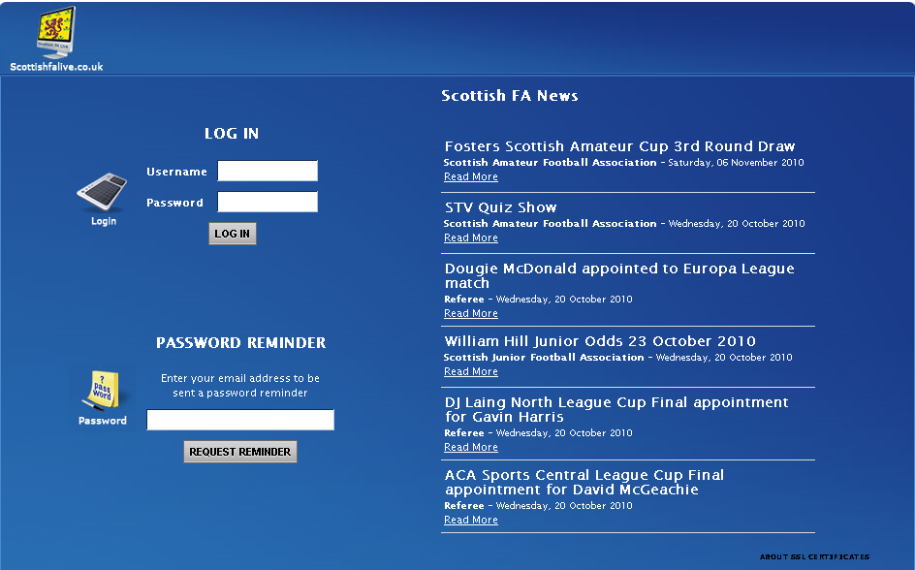
Figure 1 - Login Page

Enter the clubs Username and Password and click LOGIN. If login fails the page will display the following error message.

Your login was not recognised, please try again.
If you have forgotten any of your login details then you should contact the Scottish Women’s Football (swfreg@scottish-football.com).

Home Page

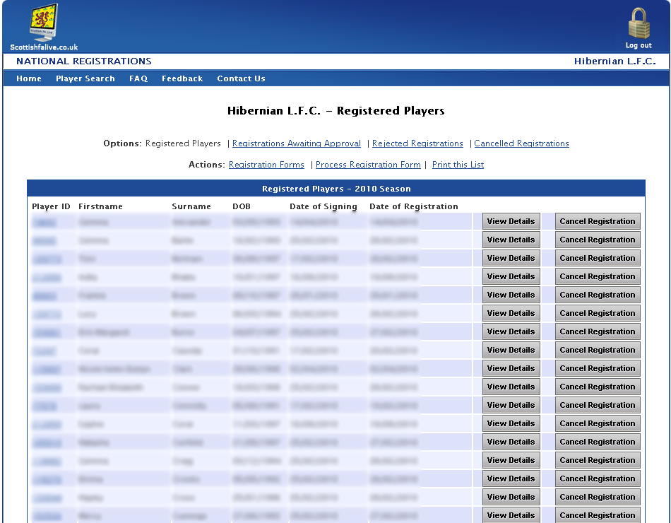
Figure 2 - Home Page

The Home page (figure 2) displays, by default, a list of all your club’s currently Registered Players.

Selecting the ‘View Details’ button next to a player will take you to that player’s Player Details page.

Selecting the ‘Cancel Registration’ button next to a player will take you to the Registration Cancellation page.

From the ‘Options’ menu you can choose to view either Registered Players, Registrations Awaiting Approval, Rejected Registrations or Cancelled Registrations.

From the ‘Actions’ menu you can choose either Registration Forms (where you will create either a blank or a pre-filled registration form), Process Registration Form (where you will process a previously created registration form), or you can print the current list of players.

Note: During the period 1st November through 31st December a drop-down will appear asking you to select which season you want to view your list of players for, the current season or the forthcoming season.

Player Details

The user is able to edit a player registered for their club by selecting the ‘View Details’ option next to the desired player on the Registered Players page.

The user can then add/edit that player’s address and contact details. Once done, select the ‘Save’ button to save any changes. Name and DOB details cannot be edited, so if they are incorrect please inform (swfreg@scottish-football.com).

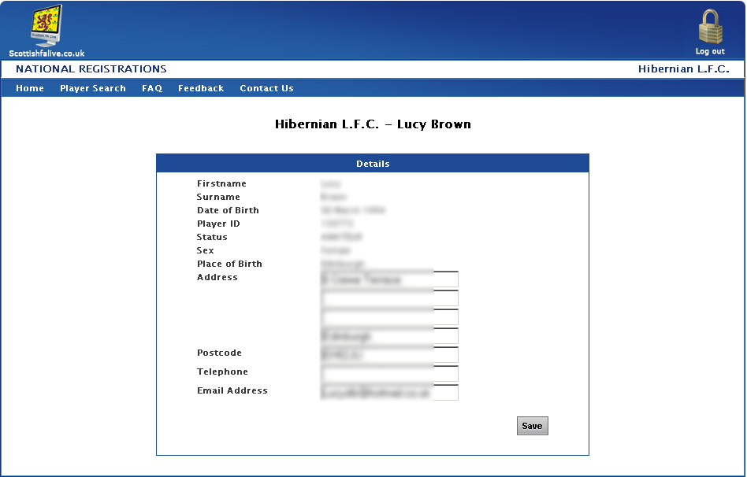
Figure 3 – Player Details Page

Registrations Awaiting Approval

The Registrations Awaiting Approval page (figure 4) shows any players who have been submitted for registrations by your club and are awaiting to be approved by the Scottish Women’s Football. Players are not registered or eligible to play till approval has been granted by the SWF.

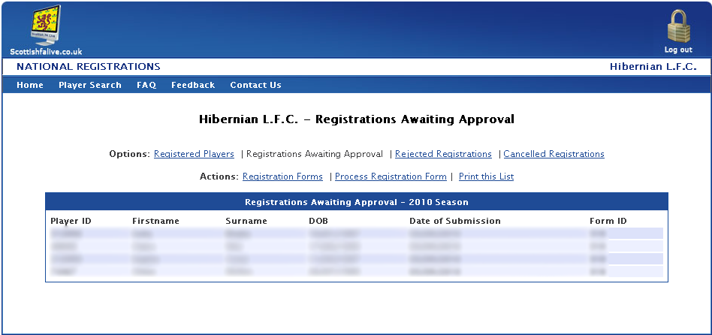
Figure 4 – Registrations Awaiting Approval Page

Rejected Registrations

The Rejected Registrations page (figure 5) shows any players that have had their registration rejected, along with the date it was rejected and the reason for rejection.

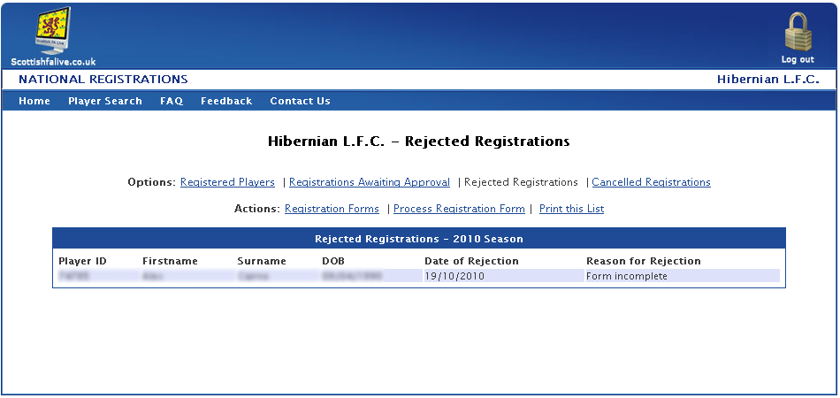
Figure 5 – Rejected Registrations Page

Cancelled Registrations

The Cancelled Registrations page (figure 6) shows any players that have had their registration cancelled, along with the date of cancellation.

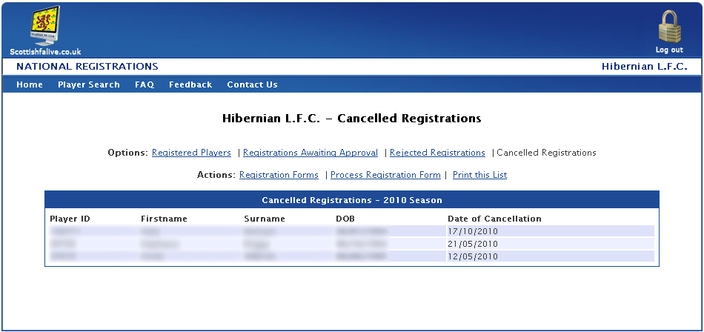
Figure 6 – Cancelled Registrations Page

‘Print this List’ Option

Selecting the ‘Print this List’ option from the ‘Actions’ options bar allows the user to print a list of players on the current page.

Cancel a Registration

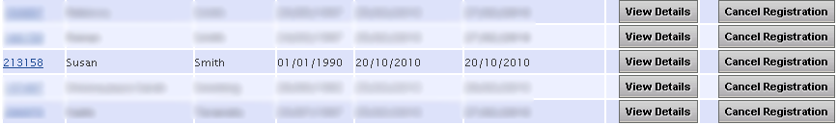
Figure 7 - Cancel a Registration

In order to cancel a player’s current registration use the following steps:

- Select the ‘Cancel Registration’ button next to the desired player.
- Ensure that the player’s details on the Registration Cancellation page (figure 8) are correct and the right player has been selected.
- Enter the Date of Cancellation and select the ‘Cancel Registration’ button.

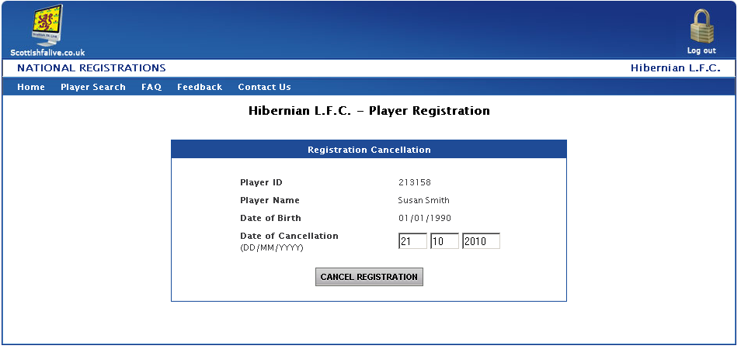
Figure 8 - Cancel a Registration: Cancellation Form

The user will then be displayed a message confirming that the player’s registration has been cancelled and they will no long appear on the club’s list of players.

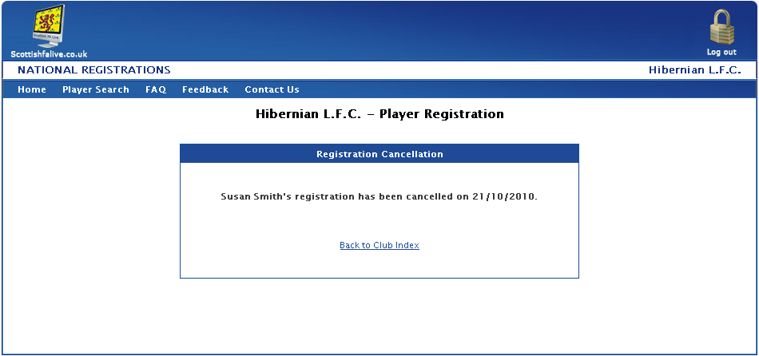
Figure 9 - Cancel a Registration: Confirmation Page

Registration Forms

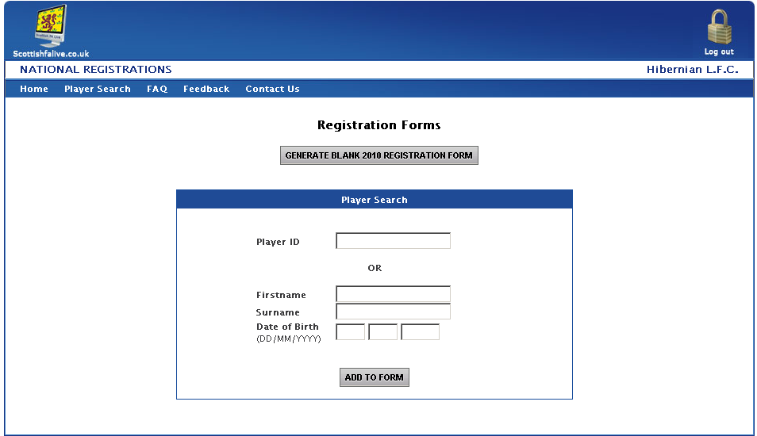
Figure 10 – Create Registration Form

There are two methods of creating a registration form, either producing a blank registration form or a pre-filled registration form.

Pre-Filled Registration Form

Any player that is currently in the Scottish FA database can have their details automatically inserted onto the form by entering either their Player ID number OR entering the player’s Firstname, Surname and Date of Birth.

If the player is eligible to register with your club then their details will appear on the page and a ‘Generate Form’ button will appear (figure 11) or else a message will be displayed informing you why the player cannot be selected for submission. Please remember to update contact details if necessary and add email address.

You can remove a player from a pre-filled form before generating the form by selecting ‘Remove Player’ next to the player you wish to remove.

Once you have added the desired players click ‘Generate Form’ to create your printable Registration Form.

Please use separate forms for players who have previously been registered with your club and new players.
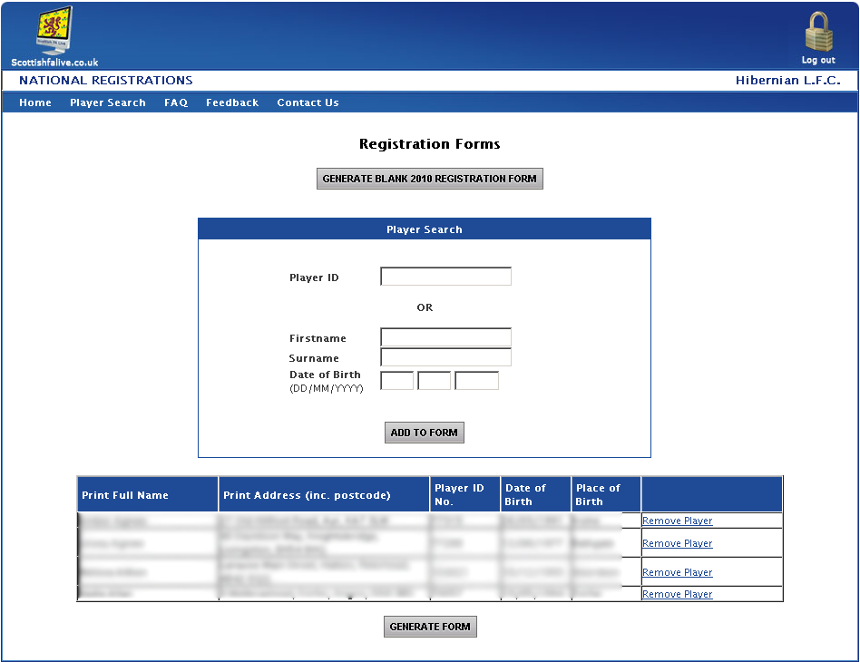
Figure 11 – Pre-Filled Registration Form Process

Blank Registration Form

Any player that is not in the Scottish FA database will need to be submitted for registration using a blank registration form.

Click the ‘Generate Blank Registration Form’ button for the relevant season and this will open a new window where you can download your printable registration form.
Process Registration Form

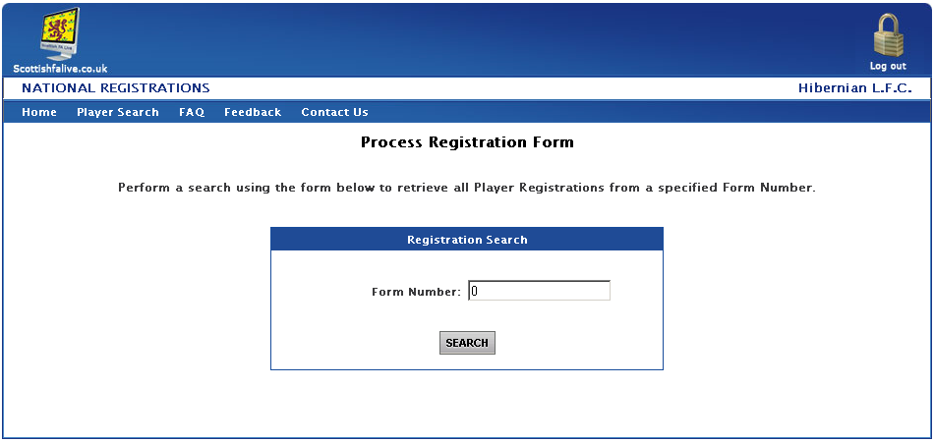
Figure 12 – Process Registration Form Page

The Process Registration Form section facilitates the submission of registrations for approval to the Scottish Women’s FA.

To submit a registration, enter the Form Number and select ‘Search’.

You will then be directed to one of two screens depending on the type of form that was created. If the form created was a blank registration form then you will be directed to a 3-step registration process (figures 13 to 17) or else if it was a pre-filled form the players from the form will be displayed.

Blank Registration Form

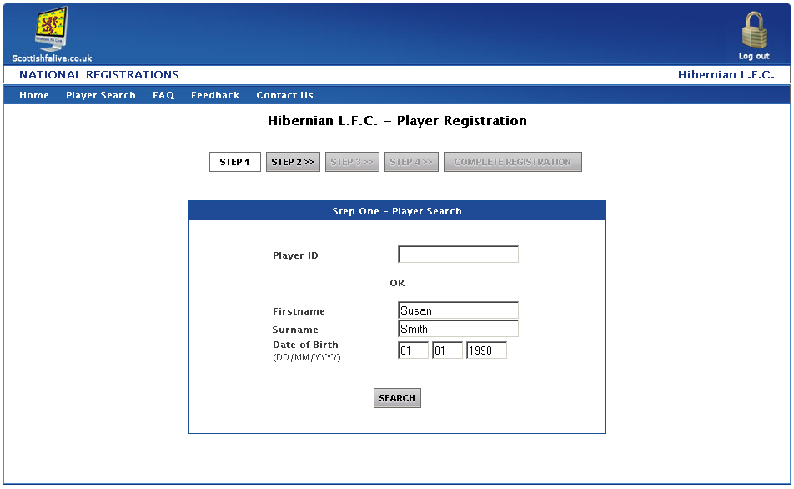
Figure 13 - Register a Player: Step One

Step One

To register the player the user will enter either:

- Player ID number

OR

- Player Firstname, Surname and Date of Birth.

A check will be performed to ensure that the player is eligible to be registered.

All player registration queries should be performed using the Player Search function to determine the player’s eligibility before attempting to register them.

If the player is eligible to be registered then the user will move to step two of the registration process.

Step Two

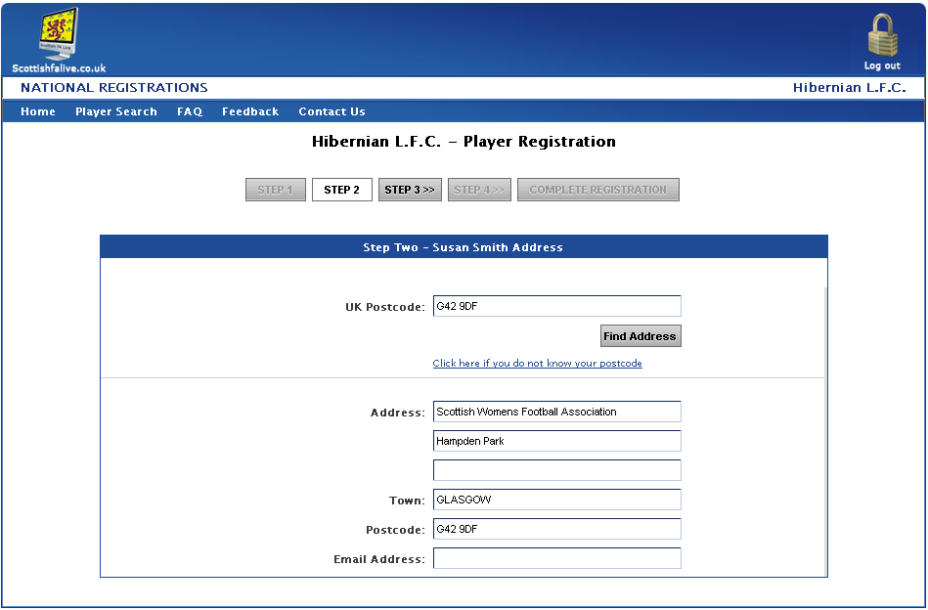
Figure 14a - Register a Player: Step Two

If the player already exists in the database then the fields will be automatically show the address details that are stored for them.

If they do not already exist then the user will need to enter the player’s details. This is done by entering the player’s postcode and selecting Find Address. This will then return a list of all addresses for that postcode. Select the address by either clicking on the address, or selecting it from the drop-down list.

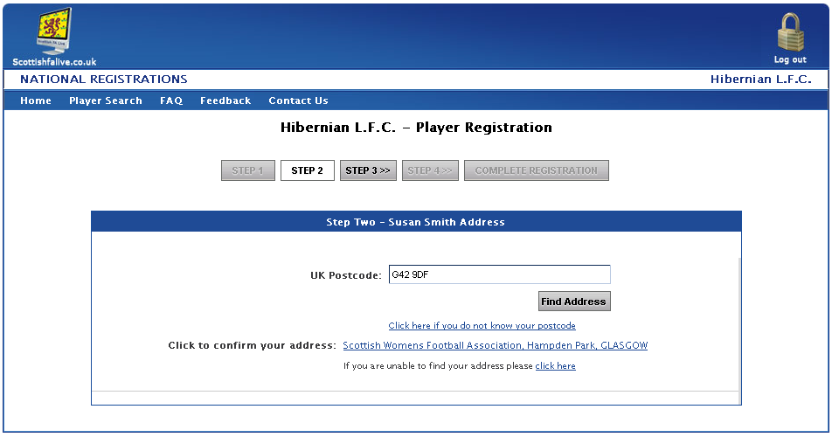
Figure 14b - Register a Player: Step Two

If you do not know the player’s postcode you can search the address by selecting the ‘Click here if you do not know your postcode’ option and entering House No/Name, Street and Town.

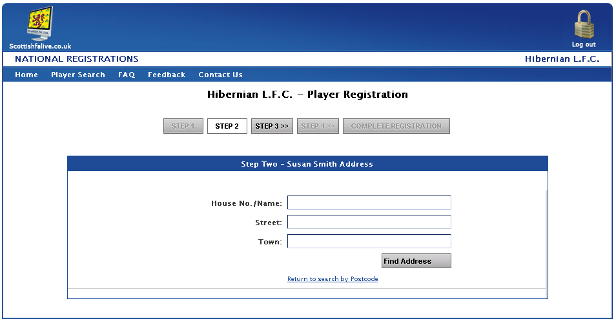
Figure 14c - Register a Player: Step Two

Step Three
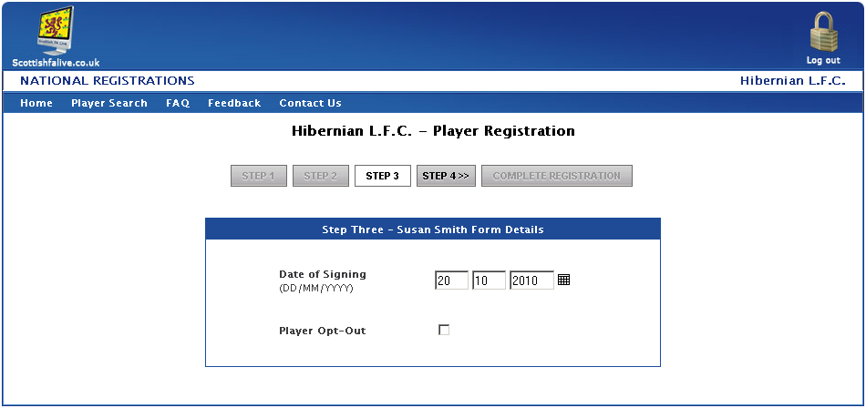
Figure 15 - Register a Player: Step Three

Step Three (fig. 15) requires the user to enter the Date of Signing. It also requires the user to select whether the player has opted out of being contacted by the Association when they signed the Player Registration form.

Upon entering these details and selecting to move to Step Four the user will be prompted to confirm that the date entered is correct.

Step Four
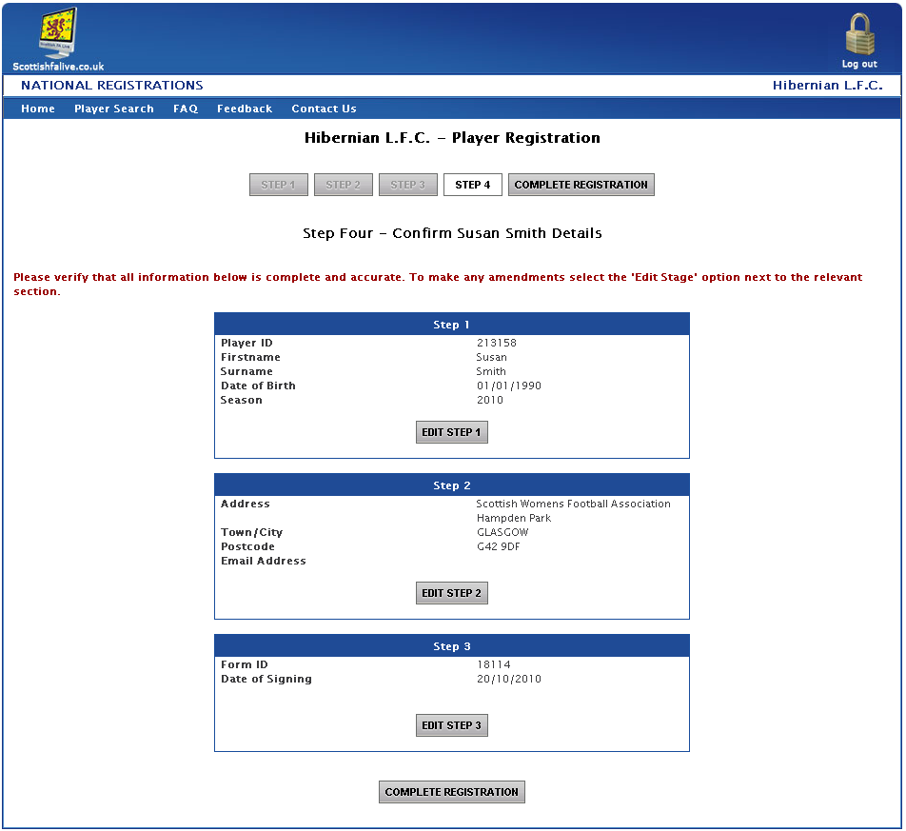
Figure 16 - Register a Player: Step Four

Step Four provides the user with an overview of all data entered so far and gives the option to go back and edit a specific step if an error has been made.

Once all the data is correct then selecting the ‘Submit Registration’ button that will submit the registration for approval to the SWF. The player will now appear in the Registrations Waiting Approval list.

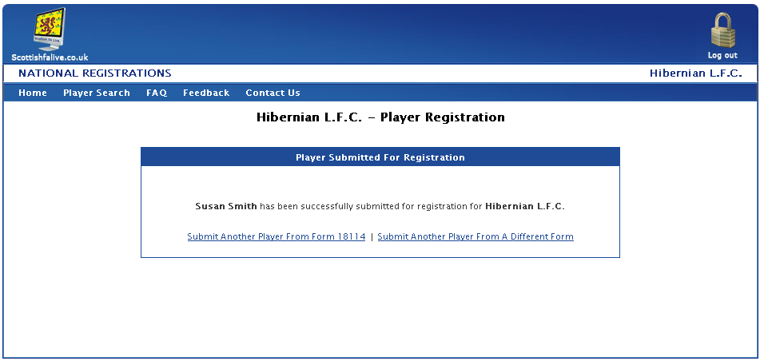
Figure 17 – Register a Player: Player Submitted for Registration

Pre-Filled Form

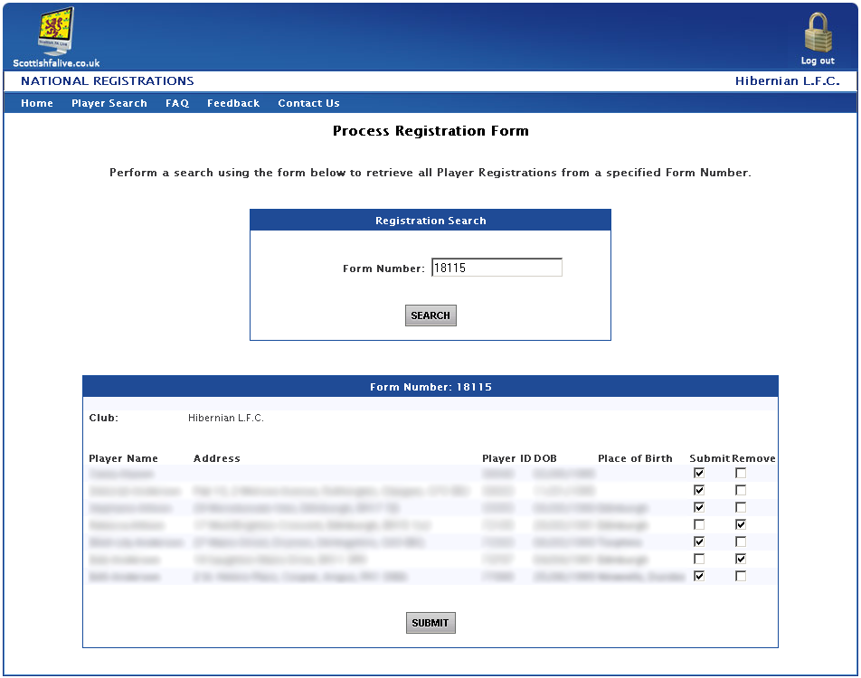
Figure 18 – Process Pre-Filled Registration Form Page

If the form created was a pre-filled registration form then the players that were on that form will be displayed. The user must then select whether they wish to continue to submit the player for registration or remove them from submission by selecting the relevant checkbox next to each player. Check players details (i.e. address and email) before submitting the form or if the details need updated

An action must be performed against all players before the system will allow you to progress by clicking the ‘Submit’ button.

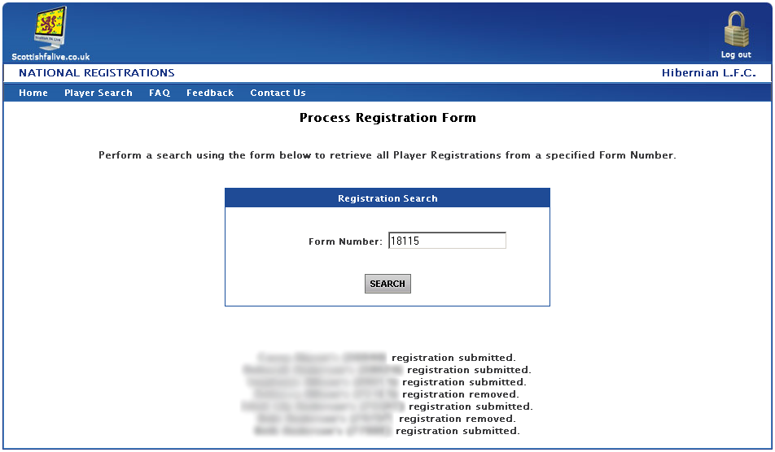
Figure 19 – Processed Pre-Filled Registration Form Page

Once a form has been submitted, the form is no longer available to edit again. Any players submitted for registration will now appear on the Registrations Pending Approval page, until such time as they have been processed by the SWF.

The club should now gather all required signatures and submit the form by post, fax or scan to the Scottish Womens Football within three days
Player Search

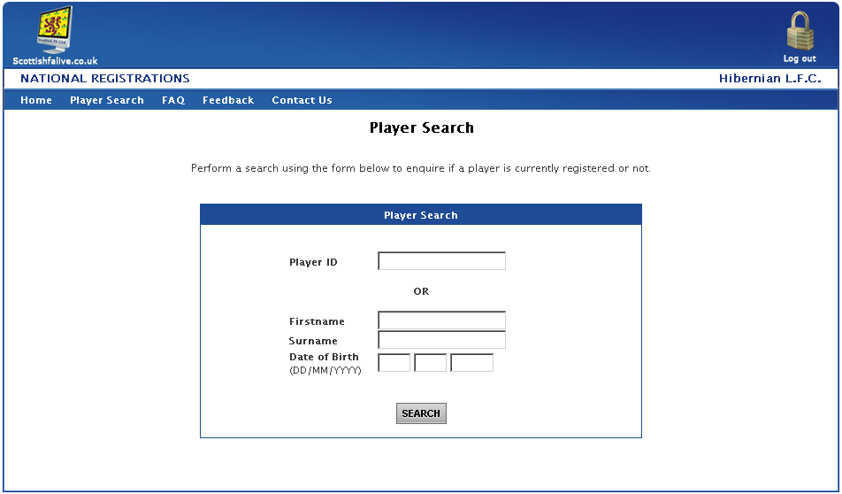
Figure 20a - Player Search Page

The Player Search section provides the user with the functionality to query a player’s current registration details.

To perform a search either:

- Enter the Player’s ID number and select the ‘SEARCH’ button.
OR

- Enter the Player’s Firstname and Surname and select the ‘SEARCH’ button.

OR

- Enter the Player’s Firstname, Surname and Date of Birth and select the ‘SEARCH’ button.

A message will be returned to the user informing them if the player is eligible to be registered or not with your team, and if not it will display the reason why.

If there is more than one player found then a list of all search results will be displayed (figure 20b) and the user must then select ‘Search’ next to the relevant player and then perform a search to establish that player’s eligibility.

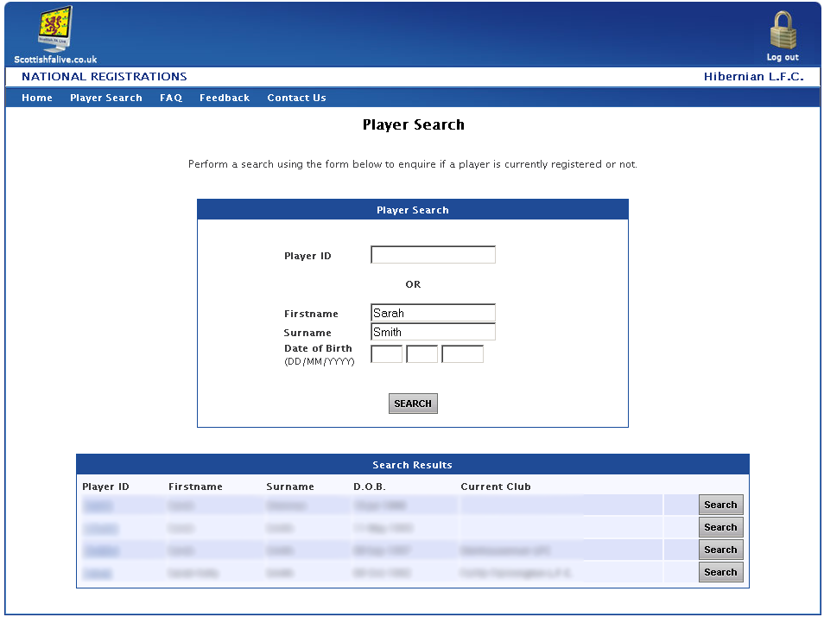
Figure 20b – Player Search Results

The user can click on a Player’s ID to open his Player Passport to view her previous registration history as a method of ensuring the correct player is selected.

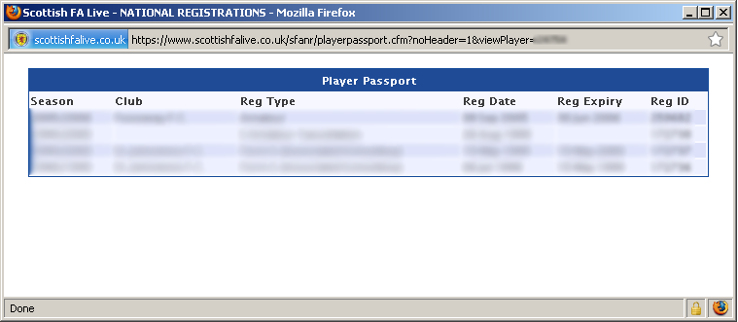
Figure 21 – Player Passport Screen

FAQ

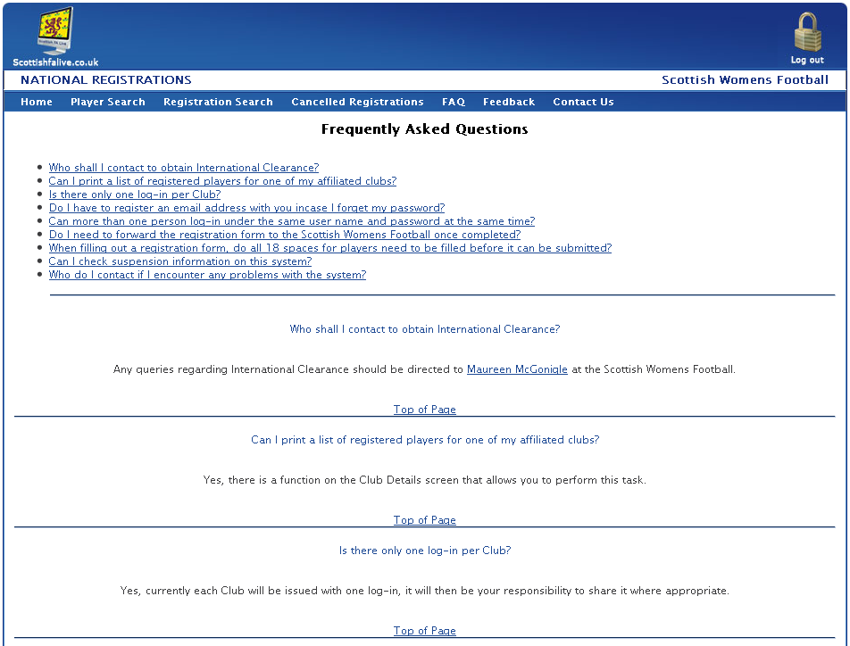

The Frequently Asked Questions section provides the user with a set of commonly asked questions regarding the National Registrations system, and the response.

This should be used to check any queries a user may have in the first instance, and if it does not solve their query then they should contact the appropriate person – whose details can be found on the Contact Us page.

Feedback

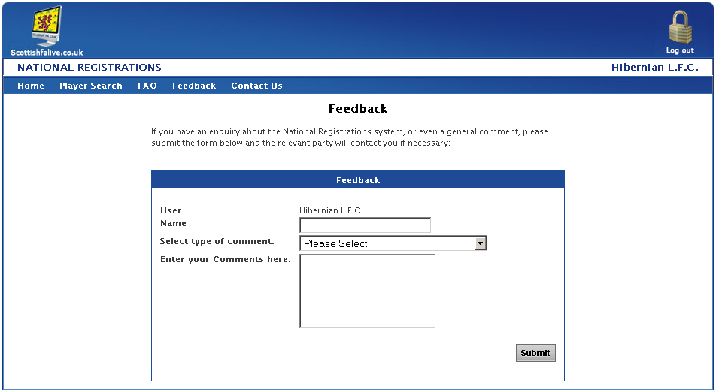

This page will allow National Registration users to contact the I.T. department of the Scottish FA.

Enter the name of the person commenting.
Select the type of comment from:

- General Comment about the Site
- Features you would like to see added
- Usability of the Site
- Problem with the Site
- Other

The comments can be typed into the box.

The Scottish FA I.T. Department will receive the message and respond as soon as possible.

Contact Us
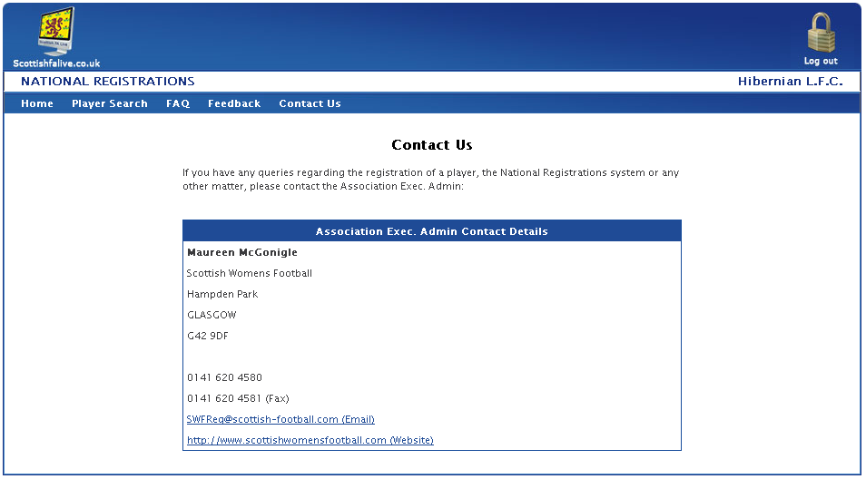

The Contact Us page contains the information for contacting the appropriate point of contact.

Logout


Clicking Logout on the Menu will log out the user and return them to the Login Page.

